Lab 8: Managing HDFS Quotes

Objective: To configure, test, and monitor HDFS storage name and space quotas

[root@golden-node1 ~]# su - hdfs

[hdfs@golden-node1 ~]$ hdfs dfs -mkdir /user/qtests

[hdfs@golden-node1 ~]$ hdfs dfs -ls /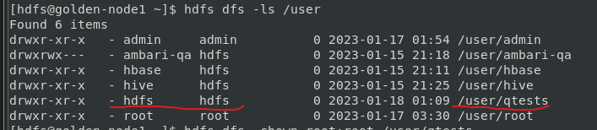

Assigning Quotes

Assign name and space quotas to the newly created directory.

[hdfs@golden-node1 ~]$ hdfs dfs -chown root:root /user/qtests

[hdfs@golden-node1 ~]$ hdfs dfs -ls /user

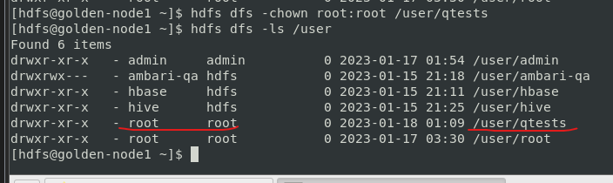

[hdfs@golden-node1 ~]$ hdfs dfsadmin -setQuota 4 /user/qtests

[hdfs@golden-node1 ~]$ hdfs dfsadmin -setSpaceQuota 134352500 /user/qtests

[hdfs@golden-node1 ~]$ hdfs dfs -count -v -q /user/qtests

* dfsadmin -setQuota command to assign a name quota to the HDFS /user/qtests directory. Set the name quota to 4 for testing purposes

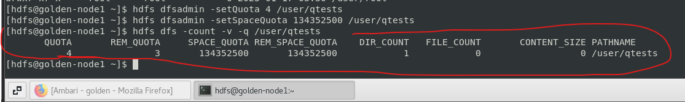

[hdfs@golden-node1 ~]$ exit

Testing Quota

Upload multiple files to the directory until both the space and name quotas are exceeded.

[root@golden-node1 ~]# hdfs dfs -put constitution.txt /user/qtests/file1

[root@golden-node1 ~]# hdfs dfs -ls /user/qtests

[root@golden-node1 ~]# hdfs dfs -count -v -q /user/qtests

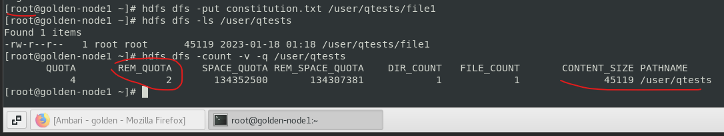

[root@golden-node1 ~]# hdfs dfs -put constitution.txt /user/qtests/file2

[root@golden-node1 ~]# hdfs dfs -ls /user/qtests

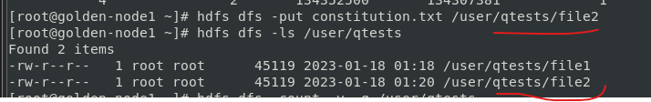

[root@golden-node1 ~]# hdfs dfs -count -v -q /user/qtests

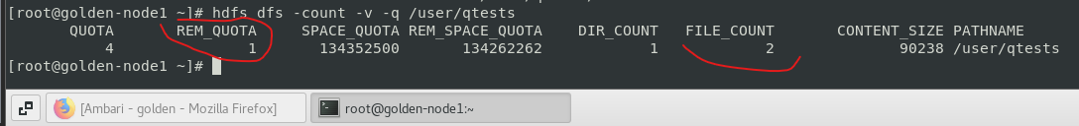

[root@golden-node1 ~]# hdfs dfs -put /home/hpcsa/Downloads/mysql-connector-j-8.0.31-1.el7.noarch.rpm /user/qtests/file4



